**Field Notes – Team Annex**

**Interview 1**

Interviewer: Brian Olsen Interviewee: Pat Ripley

1. What is your major? Computer Science
2. What class are you currently in? Freshmen
3. How many years of computer experience do you have? Almost all life
4. What kind of internet browser do you use? Chrome
5. What other software do you use regularly? Music editing software (Audacity)
6. Do you own a tablet? No, but has used one
   1. If so, how long? N/A
7. How long have you attended SIUE? 2nd Semester
8. Are you familiar with the Engineering Building? Pretty familiar
9. Have you ever used a touch screen interface? yes
   1. Which do you prefer; touch screen or mouse and keyboard? Mouse and keyboard
10. On a scale of 1 to 5 (1 – Very Difficult, 5 – Very Easy) in your opinion…
    1. How hard is it to navigate around the engineering building? 4
    2. How difficult is it to use a touch screen interface? 4
    3. How hard is it to use a mouse and keyboard? 5
11. Would you think that adding an interactive touch kiosk at the entrances of the building would really assist students in their day-to-day lives? Overall it would help
12. What is more important in an application like this…
    1. A) Simple to use interface with very little information, or

B~~) Less simple interface with more information?~~

* 1. A) More content in one window, or

B) ~~Multiple windows with less content?~~

* 1. A) ~~More images and animation to get the users attention, or~~

B) Just what’s needed to provide

1. When viewing a floor plan, would it be easier to tell the rooms apart if they were color-coded? Yes
   1. If so, which colors would best differentiate the rooms? Make sure consecutive rooms are different colors and if you want to highlight a specific room you can have a darker color and lighter colors
2. Describe a day in your shoes as a student… first semester there had three classes in the engineering building and two were in the basement and one was in the auditorium. It was difficult to find the auditorium the first time. Make something easier to use find the auditorium.
3. What information would you like to see about the…
   1. Instructors - office hours
   2. Staff- Role
   3. Administration - Role, Department
   4. Vending Machines (Snacks, distribution companies etc..)? not necessary it might clutter things
4. How would you prefer to get directions from the current location to a certain room using the kiosk? More instructional but some visual maybe
5. Is there any other information that would be useful to know when viewing the rooms, besides the classes and meeting times of the classes? Not really
6. As a potential user of this software, what would you consider to be the most useful or important part of this software? Simplicity is key
   1. Why do you consider this important/useful? To be friendly to many different types of users and skill levels
7. What is something you wouldn’t like to see in the software? Not a long loading period
8. Are there any other issues you feel are important that we didn’t talk about? Not really
9. Watcher Notes: For the directory we can have a “iphone” list feel (think in terms of email app on iphone) shows Directory list with big titles will take you down to subdirectories. Below is a rough sketch of we pulled from the interview.

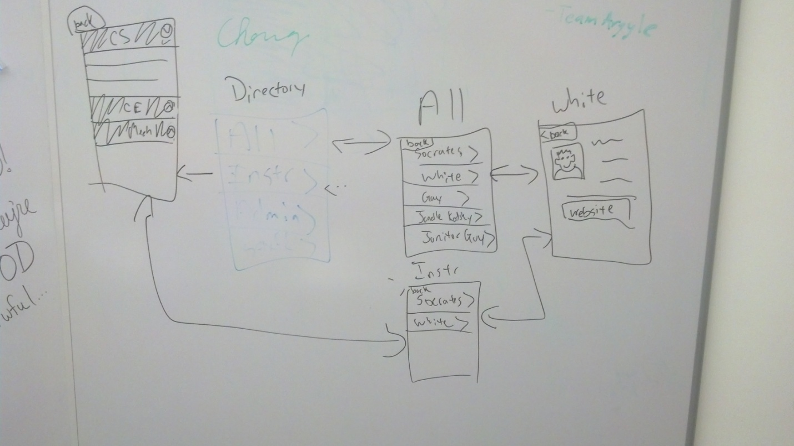

**Interview 2**

Interviewer: Josh Koehn Interviewee: Luke Lack

1. What is your major? Computer Science
2. What class are you currently in? Sophomore
3. How many years of computer experience do you have? 6 years
4. What kind of internet browser do you use? FireFox
5. What other software do you use regularly? Word, Microsoft, power point,
6. Do you own a tablet? No, but have used one before
   1. If so, how long? N/A
7. How long have you attended SIUE? 1 1/2 years
8. Are you familiar with the Engineering Building? Yes
9. Have you ever used a touch screen interface? Yes
   1. Which do you prefer; touch screen or mouse and keyboard? Simpler things – touch screen - - tough things mouse and keyboard
10. On a scale of 1 to 5 (1 – Very Difficult, 5 – Very Easy) in your opinion…
    1. How hard is it to navigate around the engineering building? 3
    2. How difficult is it to use a touch screen interface? 5
    3. How hard is it to use a mouse and keyboard? 5
11. Would you think that adding an interactive touch kiosk at the entrances of the building would really assist students in their day-to-day lives? Yes it would help
12. What is more important in an application like this…
    1. A) ~~Simple to use interface with very little information, o~~r

B) Less simple interface with more information? If it is too simple then what is the point?

* 1. A) ~~More content in one window, or~~

B) Multiple windows with less content?

* 1. A) ~~More images and animation to get the users attention, or~~

B) Just what’s needed to provide information?

1. When viewing a floor plan, would it be easier to tell the rooms apart if they were color-coded? Yes
   1. If so, which colors would best differentiate the rooms? Classrooms a certain color, labs, and offices
2. Describe a day in your shoes as a student… Freshmen English class. Very intimidating
3. What information would you like to see about the…
   1. Instructors (Current/Future courses, Department, Research, etc…)? Office hours no more
   2. Staff - Role, Department
   3. Administration - Role, Department, phone number, maybe a hierarchy
   4. Vending Machines - distribution companies , not important but helpful maybe water fountains…
4. How would you prefer to get directions from the current location to a certain room using the kiosk? Both written directions and visual directions
5. Is there any other information that would be useful to know when viewing the rooms, besides the classes and meeting times of the classes? Times classes – if a class is getting cancelled?
6. As a potential user of this software, what would you consider to be the most useful or important part of this software? Finding professors, with their information.
   1. Why do you consider this important/useful? To find them
7. What is something you wouldn’t like to see in the software? (If you have used a navigation application before try to have them focus on what they don’t like about that.) Vending machine info may be too much…
8. Are there any other issues you feel are important that we didn’t talk about? Not really, map may be really strange while looking for an instructor, Emergency exits display??
9. Is there any other features, not mentioned, that would be beneficial for new students?
10. Are there any other features that would be beneficial for those already used to the building?
11. If you could have one design wish for this software what would it be?
12. Do you have any questions for us? Where would the kiosks really be located??
13. Watcher Notes: How will we do the visual aspect of the directions? Pictures? Possibly a Google maps approach to showing different levels?

**Interview 3**

Interviewer: Rick Blotevogal Interviewee: Stuart Poss

1. What is your major? Computer Science
2. What class are you currently in? Sophmore
3. How many years of computer experience do you have? 2 years
4. What kind of internet browser do you use? Firefox
5. What other software do you use regularly? Not much software, webbrowsing
6. Do you own a tablet? no
   1. If so, how long?
7. How long have you attended SIUE? 3 years
8. Are you familiar with the Engineering Building? Somewhat familiar
9. Have you ever used a touch screen interface? yes
   1. Which do you prefer; touch screen or mouse and keyboard? Touch screen
10. On a scale of 1 to 5 (1 – Very Difficult, 5 – Very Easy) in your opinion…
    1. How hard is it to navigate around the engineering building? 3
    2. How difficult is it to use a touch screen interface? 4.5
    3. How hard is it to use a mouse and keyboard? 4
11. Would you think that adding an interactive touch kiosk at the entrances of the building would really assist students in their day-to-day lives? I think so… as long as it’s not visually cluttered and can be related to the real thing, Make sure the information about the instructors is thorough
12. What is more important in an application like this…
    1. A) ~~Simple to use interface with very little information, or~~

B) Less simple interface with more information?

* 1. A) ~~More content in one window, or~~

B) Multiple windows with less content?

* 1. A) ~~More images and animation to get the users attention, or~~

B) Just what’s needed to provide

1. When viewing a floor plan, would it be easier to tell the rooms apart if they were color-coded? yes
   1. If so, which colors would best differentiate the rooms? No preference
2. Describe a day in your shoes as a student… It was a little confusing but for day to day life he found the classrooms and labs with moderate difficulty but after that it was simple.
3. What information would you like to see about the…
   1. Instructors - mailbox number, sufficient information
   2. Staff – Role, TA information
   3. Administration - contact information
4. How would you prefer to get directions from the current location to a certain room using the kiosk? Visual, with directions (virtual tour style)
5. Is there any other information that would be useful to know when viewing the rooms, besides the classes and meeting times of the classes? Not really
6. As a potential user of this software, what would you consider to be the most useful or important part of this software? Layout is most important
   1. Why do you consider this important/useful? Understanding of how the software is useful... less confusing for someone to come in and relate the layout to the actual building
   2. What would you like it to show first? SIUE logo some directions on what to do so they know it’s not advertisement that it’s a tool to use
7. What is something you wouldn’t like to see in the software? (If you have used a navigation application before try to have them focus on what they don’t like about that.)
8. Are there any other issues you feel are important that we didn’t talk about? Engineering building hours
9. Is there any other features, not mentioned, that would be beneficial for new students? Layout of the floor
10. Are there any other features that would be beneficial for those already used to the building? Knowing instructor availability
11. If you could have one design wish for this software what would it be?

Pictures of the instructors to go along with their information, and a brief description of their background and research

1. Watcher Notes: Provided beneficial information in regards to what information to put about instructor and staff.